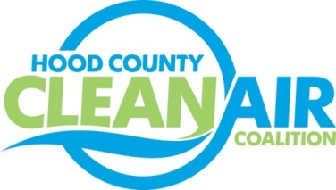
Meeting: Thursday, August 3, 2017
Neely House
304 East Rucker Street, Granbury, Texas 76048
8:30-10:00 a.m.

Agenda

- Call Meeting to Order
- EPA Updates – Randy Pitre, EPA
- Local Updates – Michelle McKenzie
  - Review of July Meeting Summary
  - Reports
    - July Ozone Update
    - Air North Texas Meeting
    - EPA Webinar: NAAQS Designations
  - Annual Minutes
  - Review of Projects
    - Monthly Budget Review for June
    - Status of Projects FY 16/17
- Regional Updates – Michelle McKenzie
  - Air Quality Funding Opportunities: www.nctcog.org/aqfunding
  - Fleets for the Future (F4F)
- Loss of Rider 7 Funding
- Other Discussion
- Adjourn

